SUCCULENTS

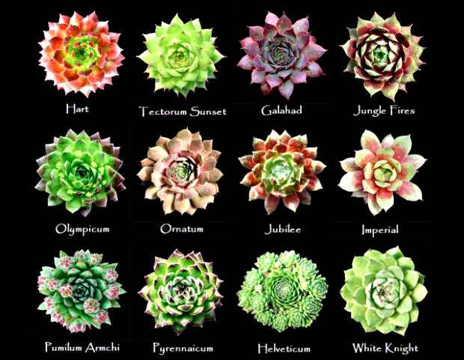

Succulents are much more cold-tolerant than most people assume. Native to desert climates, which can have very cold nights, they can withstand temperatures down to even 40ºF. Ideally, succulents prefer daytime temperatures between 70ºF and about 85ºF and nighttime temperatures between 50ºF and 55ºF.

Succulents prefer bright light, such as found on a south-facing window. Watch the leaves for indications that the light is adequate. Some species will scorch if suddenly exposed to direct sunlight. The leaves will turn brown or white.

Alternatively, an underlit succulent will begin to stretch, with an elongated stem and widely spaced leaves. Solution: provide better lighting and prune the plant back to its original shape.

Succulents should be watered generously in the summer. The medium should be allowed to dry between waterings, but do not underwater. During the winter, when the plants go dormant, cut watering back to once every other month.

Overwatering and ensuing root rot is the single most common cause of plant failure. They may seem healthy at first, although if the soil never has a chance to dry out intermittently, succulents will surely fail.

